System Name: Task Management Application
Used Tool: WPF .NET
System Navigation Flow:
Database: create two tables User and Tasks.
- User table has the following attributes:
  - UserID (Primary Key, int)
  - Name (nvarchar, required)
  - Password (nvarchar, required)
  - Email (nvarchar, required, unique)
  - Role (nvarchar, options: Manager, Employee)
- Tasks table has the following attributes:
  - TaskID (Primary Key, int)
  - Title (nvarchar, required)
  - Description (nvarchar, optional)
  - Status (nvarchar, options: Pending, In Progress, Completed)
  - DueDate (datetime)

- Log In Page
  - The user enters their username and password.
  - Based on the user’s role, they are directed to different pages:
    - If the user’s role is Employee, they are directed to the View Tasks page.
    - If the user’s role is Manager, they are directed to the User Management page.

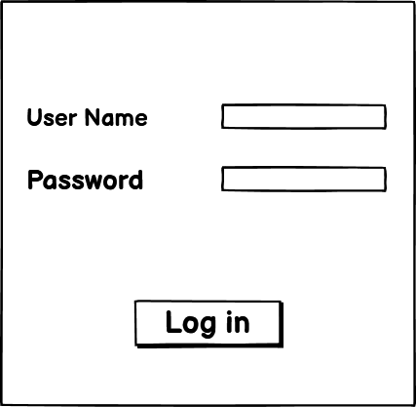

Page Descriptions:
- View Tasks Page (for Employees)
  - The page displays the employee’s tasks, divided into two data grids:
    - The first data grid lists tasks with the statuses “Pending” and “In Progress.”
    - The second data grid shows tasks with the status “Completed.”
  - Employees can update the status of their tasks directly on this page.
    - When employee change the status to “Completed”, it will appear in the second data grid.

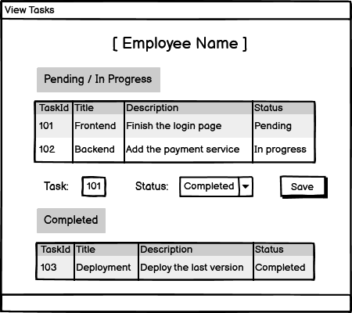

- User Management Page (for Managers)
  - The page displays a list of employees along with their assigned tasks.
  - The manager can perform task management functions, including adding, deleting, and updating tasks for employees.

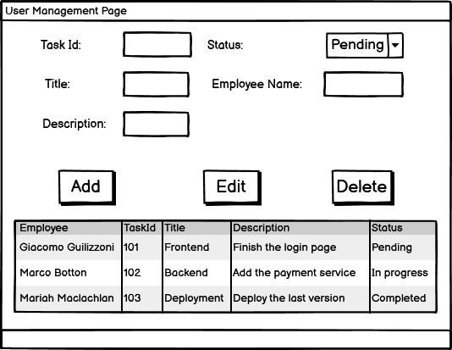

UI Controls: Using the following controls in XML is a must
- Label
- Textbox
- Combobox
- Button
- Radio button
- Grid
- Image

Style Controls: Using the following style controls in XML is a must
- Font weight
- Background
- Margin
- Border
- Foreground
- Font family

